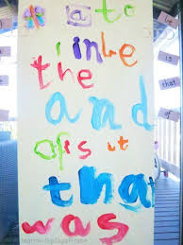

Week of May 1 to May 5, 2017
Friday May 5 No School – NBTA Council Day

Sight Words: Continue with ‘then’ ‘than’ and how to use these words in a sentence, ‘than’ is when comparing something to something else. Continue with ‘liked’ ‘likes’.
New words: day, today, say, play and my.

For your sight word activity this week. Have your child paint sight words. I will include a large painting sheet in your child’s communication bag or paint on any surface you would like. Make a sight word booklet by painting each word on a single sheet of paper and letting it dry before stapling it into a sight word book! This is something your child can read again and again for practice!

Monday - Read one home reading book. Read the short vowel words from the Reading Sheet found in your child’s communication bag. See how many your child can read! Or read words only from one of the vowel sounds or some words from each of the vowel sounds.
Tuesday - Read home reading book for second night. Read from the short vowel Reading Sheet.
Wednesday - Paint Sight words!!
Thursday - Complete the Ladybug Math Sheet. Representing 9 in 5 ways. Read from the short vowel Reading Sheet.
Friday – No School for students – NB Council Day.

Have fun!! Thank your for your support!

